
Lab Report 11
Data Communication & Computer Networks


Submitted To:
Engineer Shehzad Malik
Submitted By:
Sumama Rahim
F24BSCS039
BS CS (F24-A-Morning)
Date: 12/17/2025
LAB REPORT – 11
Cisco Packet Tracer – Telnet a router

Problem:
How to telnet a router? Accessing a router remotely.
Solution:

Topology:

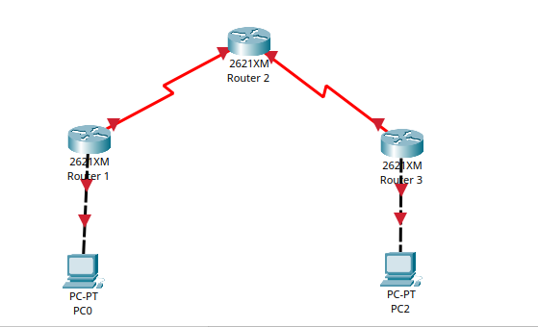

Task 1: Accessing Router 3 from Router 1

First we need to do basic IP configurations.
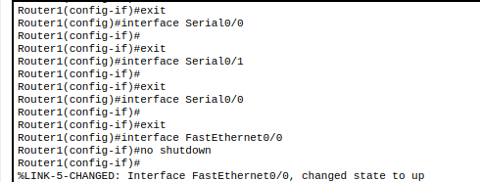

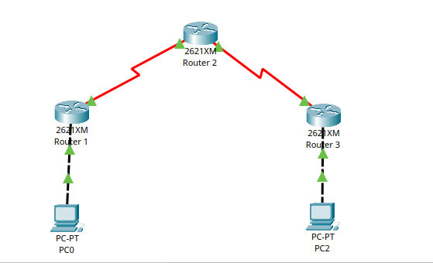

NOTE: We need two types of passwords (VTY and enable) in order to do telnet. Without these two types of password, we will not able to perform telnet.

Task 2: Setting VTY and Enable passwords

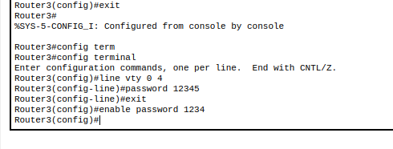

Task 3: Checking for telnetting

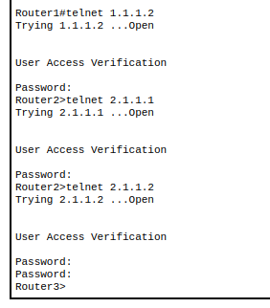
The above shows that, how we can access any (1, 2 and 3) Router from any (1, 2 and 3) Router.

Task 4: Accessing PC0 from PC1 and Vice Versa.
NOTE: Packet tracer PCs don’t support Telnet server functionality. Only network devices such as routers and switches can accept Telnet connections. Therefore, PC to PC Telnet is not possible in Packet Tracer.

Solution: Do PC to Router Telnet

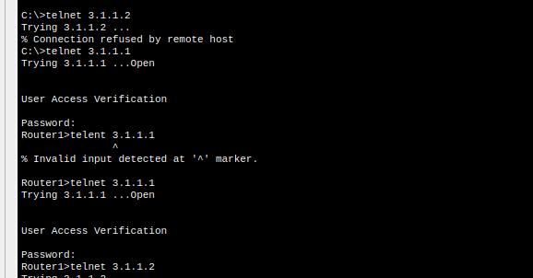

The End

